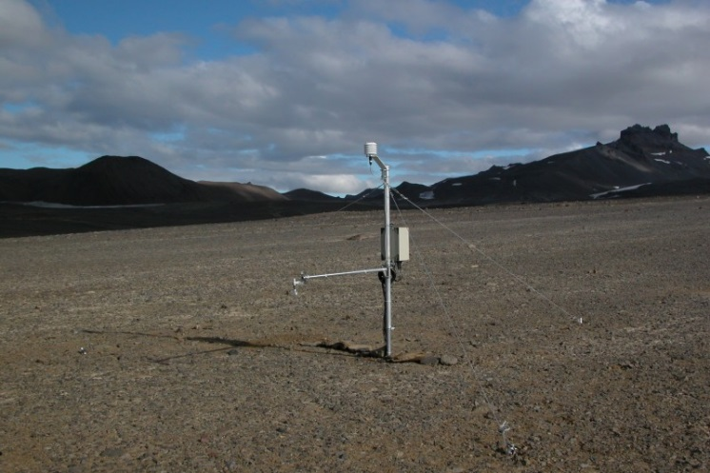Site name: Abernethy Flats
Device codes: JF; XX-snow
Coordinates: S63°52'52.9"; W57°56'53.7"
Altitude: 41 m
Site description:
The study site is located in the northern part of Ulu Peninsula, James Ross Island. Both meteorological and ground data are available. The surroundings is covered by regolith and there is open sea to the north of the study site in the distance of approx. 2,5 km.

Measured parameters:
Current setting:
JF - Air temperature and Relative humidity (200 cm) – since 11 January 2006
JF - Surface temperature – since 11 January 2006
JF - Soil temperature (5, 10, 20, 30, 40, 50 cm) – since 11 January 2006
JF - Soil temperature (75 cm) – since 6 February 2012
JF - Soil heat flux (5, 20 cm) – since 28 January 2015
XX - Snow depth – since 4 February 2016
Cancelled measurement:
AF - Air temperature and Relative humidity (200 cm) - between 4 February 2013 and 30 January 2014
JF - Soil heat flux (2 cm) – between 14 January 2006 and 28 January 2015

Measurement interval:
JF – 30 min
XX – 180 min
Total data availability: 95 %
Data quality: 2 (several errors occurred)
Missing data period: 15 September 2011 – 6 February 2012 (113 days)
Published data period: 6 February 2012 to 31 March 2015
Cited as: Hrbáček, F., Nývlt, D., Láska, K., 2017. Active layer thermal dynamics at two lithologically different sites on James Ross Island, Eastern Antarctic Peninsula. Catena. http://dx.doi.org/10.1016/j.catena.2016.06.020
Data files:
Complete time series – raw data:
JF_refin_2012.dcv (11 January 2006 to 6 February 2012)
JF_refin_2015.dcv (6 February 2012 to 28 January 2015)
JF_refin_2016.dcv (since 28 January 2015)
XX_refin_2016.dcv (since 4 February 2016)

Soil texture sampling: 29 January 2015
Soil texture results: Not Available
Soil moisture sampling: 29 January 2015
Soil moisture results: Available – Abernethy_SoilMoisture.xlsx

